**GlasgowHeart: LV reconstruction from Images**

Authors: Hao Gao

Version 0.2

**Abstract**

This document provides a short tutorial on how to generate ventricular geometry from MR images and how to do PCA analysis based on the generated geometry.

Updated based on the version used in 2017 – 2018.

Table of Contents

Section 1: access sample MR data 2

Section 2: Cardiac MR images—a simple introduction 3

Section 3: LV geometry reconstruction, for version 0.1 8

Section 4: LV geometry reconstruction, for version 0.2, from 2019 11

Preparation 11

The Main Steps 11

# Section 1: access sample MR data

MR images can be download from our local Euclid servers, in the folder

/xlwork6/heartvalve/MRIData/Healthy volunteers

Note: MR data are sensitive and confidential data, should be kept within School of Mathematics and Statistics, University of Glasgow.

To login into Euclid, you will need secure shell or using linux-type terminal

Server address: euclid-01.maths.gla.ac.uk

User name: ask IT to setup an account for you if you do not have

Password: xxx

A windows client can be download here:

<https://cloud.maths-stats.gla.ac.uk/index.php/s/tOA1WVkuV0xM5H3>

It has a nice interface to transfer the data between the linux server and your local machine

If you are using mac, you can connect the Euclid server using terminal, and cyberduck to download the files from the servers.

After downloaded the MRI data, you will need an image viewer,

Windows: /xlwork6/heartvalve/MRIData/Healthy volunteers/syngo_fV.zip

Mac OS: Osrix

another one is RadiAnt, recommended, quick and faster in windows

# Section 2: Cardiac MR images—a simple introduction

To reconstruct LV geometry, we will only use cine MR images (a type of images), the basic procedure is

1. load the image
2. segment the boundary
3. assembly all the boundaries into a common coordinate system
4. fit an idealized LV geometry by matching those segmented boundaries

**A schematic ventricular anatomy**

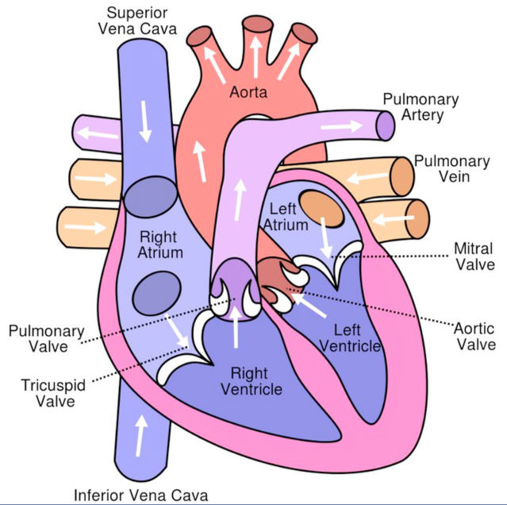

**The images we use are**

1. Long-axis image

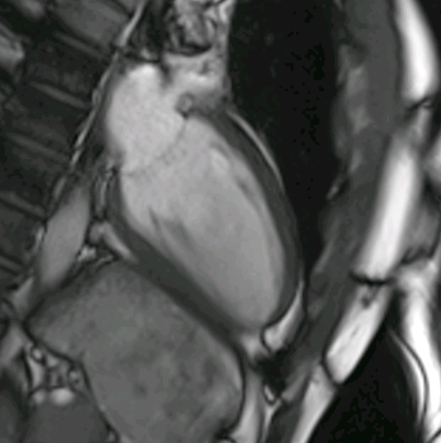

two chamber (single ventricle)

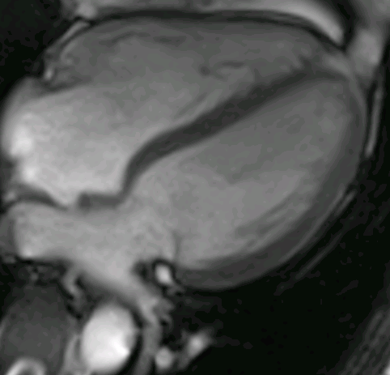

Four chambers

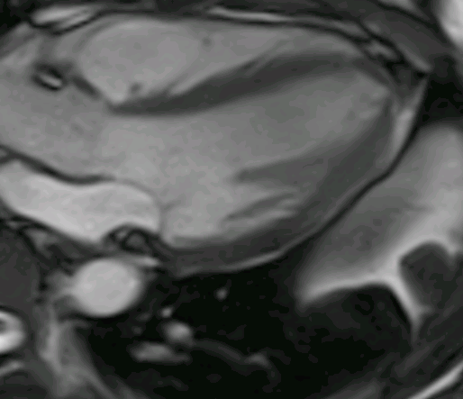

three-chambers (or called left ventricle with outflow tracts, LVOT)

1. **Short-axis images**

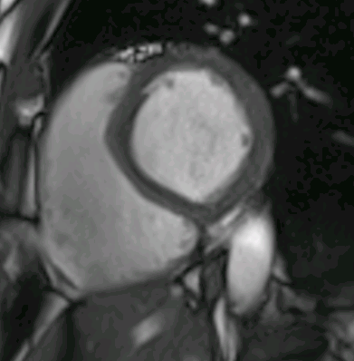

short axis images usually start from ventricular base towards LV apex, every short-axis slice usually covers 10mm region along the long-axis. In general there are 6-7 short-axis cine images to cover the whole LV geometry.

For one location (image plane), usually there are around 20+ images to cover the whole cardiac cycle, starting from end-diastole to systole, to early-diastole, and to late-diastole

Short-axis imaging plane is defined through long-axis images as

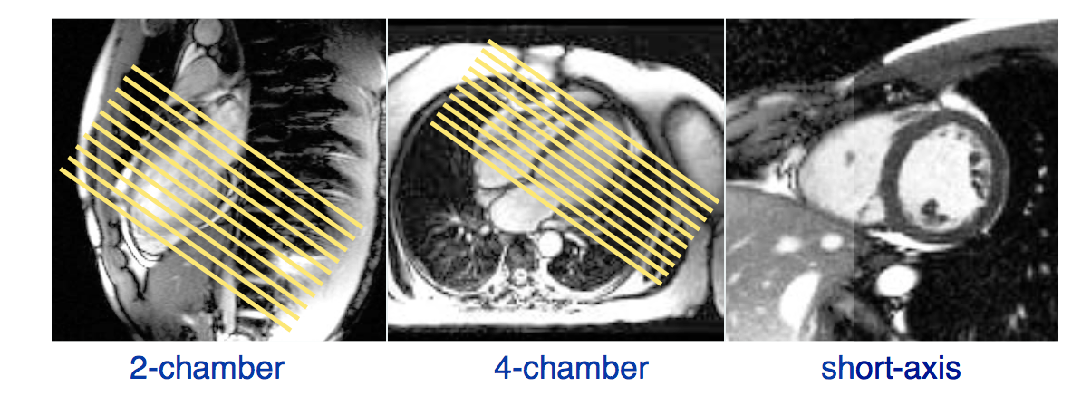

yellow lines are the imaging plane, at each plane, one set of short-axis images will be acquired with temporal resolution 45ms.

MRI cardiac Anatomy: 2 chamber view

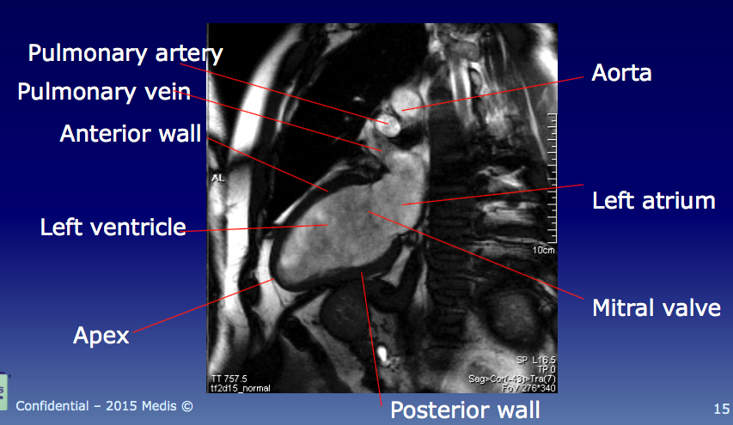

Four chamber view

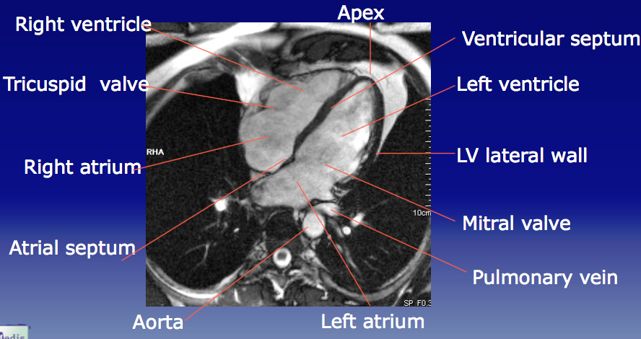

short-axis view

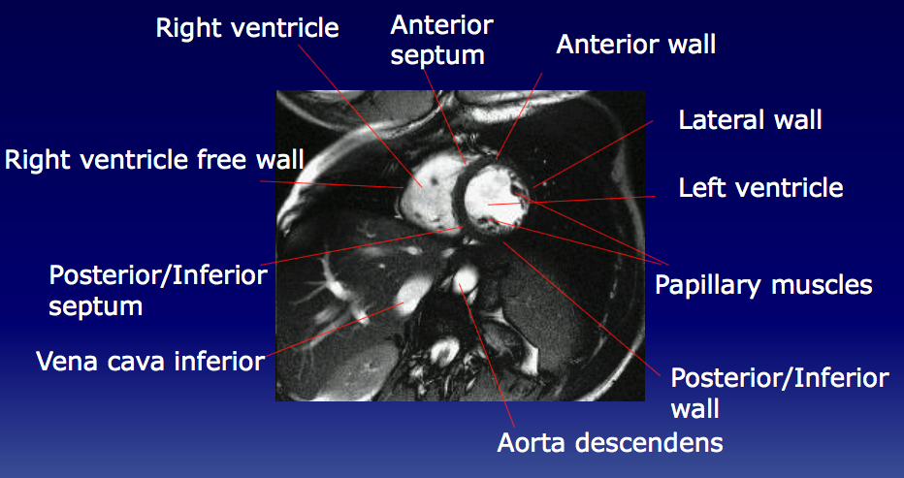

**LV region definition**

Along long-axis: basal, mid and apical

Based on short-axis: AHA 17 segments (the bottom part in the following figure)

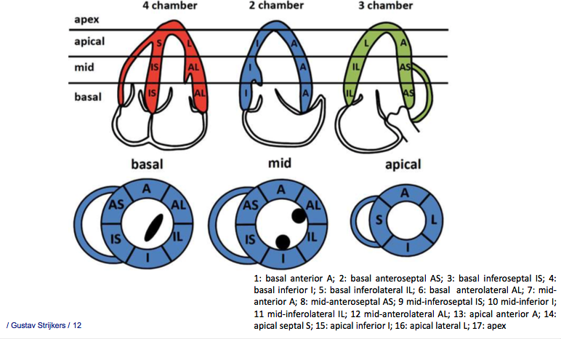

# Section 3: LV geometry reconstruction, for version 0.1

All the codes are written in Matlab, it seems Mac runs not very smooth, better with Windows, Linux has not been tested. The matlab codes are saved in PCALVModelAnalysis folder.

1. Step 1: set up a Results folder

…/some_folder/Results

1. Step 2: create a result folder to save results for one subject

…/some_folder/Results/HV03

1. Step 3: create a subfolder in HV03 to save results for the reconstructed geometry t specific cardiac time, for example, you will need to reconstruct LV geometry at early diastole

…/some_folder/Results/HV03/earlyDiastole

1. Prepare a config file for the subject, you can copy a template from /Results/HV03/LVWM_config_HV03_EarlyDia.m in the code folder
2. Update the config file, for example the LVWM_config_HV03_EarlyDia.m. Changes include

* Line 6: dicomDir = ‘the root directory of the MR images’
* Line 7: resultDirRoot = ‘…/some_folder/Results’
* Line 8: resultDir = ‘HV03/earlyDiastole’
* Lines 13 to 16 are the settings for mac, you can leave it if you are using windows. You will only need to update lines 6-7 or lines 13-16 depending on your system
* Line 42: change the name to be ‘HV03’
* Line 43: the time instance at end of systole, before the aortic valve closing, numbers can be found from the dicom viewer
* Line 44: normally will be 1
* Line 45: the time instance at early of diastole, after the aortic valve closed, and the mitral valve just opens, usually two or 3 larger than the time instance of end-systole
* Line 50: the long-axis positions, usually 3
* Line 51: the number of images for one cardiac cycle, can be found in the dicom viewer
* Lines 80-83 are for one short-axis image planes, you will only need to update the line 81, the ImgDir, which is the folder within dicomDir.
* The following codes of each block are the repetition for each short axis slices, you may need to add or comment out some blocks depending on how many short-axis slices you have
* Then the last three blocks for the three long axis images, update correspondingly.

1. Run LVWM_DicomSampleSelection. A file selection window will appear, choose the config file just prepared
2. Run LVWM_SASegManualUsingImpoint. There will be some messages printed in Matlab command console. You will need to change line 9, imSelected from 1 to the number for the last short-axis images, 6 or 7 normally, which means you will segment the LV boundary for short axis images one by one. Steps are

* Change imSelected= the number of the short-axis image you want to segment
* Run the code
* Select the config file
* Drag a rectangular shape to cover the whole LV, right click and select “crop image”.
* A new window will show the cropped image, and maximize the window, in the left side, there are two buttons, ‘stop’ and ‘re-plot’. Put a point in the endocardial boundary either clockwise or anticlockwise way, you do not need to put too many points, around 10 will be enough. Before putting the last points, click ‘stop’ button, then put the last point. Now click ‘replot’, a fitted curve will be plotted. If you are happy with the boundary, then double press ‘space’ key in the keyboard, remember make sure the window with segmented boundary is in focus (you can click the window). If you are not happy with the boundary, you can click a point, and hold ‘left mouse key’ to move that point, and then click ‘replot’. Similarily, double press ‘space’ key to finish the endocardial boundary segmentation
* A new window with segmented endocardial boundary will show. In a similar way, you can define the epicardial boundary
* After finish one short-axis image, then update imSelected to be the next short-axis image

1. Run LVWM_LASegManual. Similarly as the short-axis images, you will need to update line 13, imSelected= 1 to 3, first segment the endocardial boundary, and then the epicardial boundary
2. Run LVWM_Apex_LASegManual, first you will need to drag a rectangle to cover the whole LV, and firstly define most apical point in the endocardial boundary, then the most apical points in the epicardial boundary. Press any key to continue to define the points at different long-axis images. In total there are three long-axis images
3. Run SAAdjustmentBYLASeries, a gui interface will appear, you will need to run this code three times, each time you choose different long-axis views, from 1 to 3.

* First choose the config file,
* enter the long-axis view, from 1 to 3
* enter the short-axis image number to be corrected, suggested you start from 1, and press ‘entre’
* click DisplayImage button, you will need to move the image windows to make sure they are not overlapped. In Figure 2 window, it shows the image in 3D, and the endocardial boundary for the selected short-axis slice
* now you can click ‘move+’ or ‘move-’ to move the endocardial boundary, you will need to try to match the endocardial boundary with the corresponding boundary from the long-axis view, or try to move the boundary in the middle of the ventricle
* then enter another short-axis image number, ie 2, and press ‘enter’.
* click DisplayImage button. The window with 3D image may not update the endocardial boundary, please click ‘move +’ or ‘move -’, it will show the new endocardial boundary.
* Repeat until the last short-axis image, and click ‘show all together 3D LA’, you can check how they look like.
* Finally click ‘SAVE’, the corrected boundaries will be saved
* Repeat for other long-axis views.

After this step, the motion artefacts during MRI scan will be minimized

1. Run LVWM_SALASeg_LongAxisAlignment (choosing the config file for the current subject).
2. Run LVWM_SA_GuidPointsGeneration_LongAxisAlignment (choosing the config file for the current subject).
3. Run LV_Pre_Fitting, you will need to choose a config file. It will save a mat file in your resultDirRoot, i.e. ‘HV02_prolatePara.mat’
4. Segment all HV volunteers
5. Following the matlab file ‘estimate_global_alpha0.m’ in the resultDirRoot folder to calculate the population average value
6. Run LV_EndoFitting, then LV_EpiFitting, then LV_WholeMesh for each HV.
7. Now you can do shape analysis, an example code is provided in the subfolder ‘shapeAnalysis’, check ‘pca_analysis.m’ for details.

# Section 4: LV geometry reconstruction, for version 0.2, from 2019

## 4.1 Preparation

To reconstruct MI patients, now it becomes easier. To prepare the work

1. Locate the shared owncloud folder **segmentation_mi**, if you can not access to it, ask Alan to share with you.
2. Copy **PCALVModelAnalysis_Alan** to rename as **PCALVModelAnalysis_YourName** or Something else. You will need to delete **PCALVModelAnalysis_YourName/Results** folder to save space
3. You will need to **work within segmentation_mi folder**, so don’t move anything out of this folder, then the code will not work properly because of hard-coded directories in matlab code
4. All results are saved in **MI_Models,** each subject has a folder, within each folder, containing a config file, and the folder earlyDiastole, which will save all segmentation and reconstruction results you are going to generate.

Unlike the previous version, for all the MI patients, I have prepared all configure files and set up all related parameters, you do not need to change anything for the configure file. The matlab codes are written in a way to run in windows, linux and Mac. To save space, original MR images are not included in the shared owncloud folder, but can be downloaded from Euclid server, .

## 4.2 The Main Steps

Step 1: Segment short-axis images

1. Run All_SA_ManualSegmentation.m;
2. An open file dialogue will appear, and pointing the MI_Models folder, you will need to click the subject folder to select the configure file;
3. Then a list dialogue will appear, it starts from 1, and whenever you finish one image, it moves into next. By choosing different number, you can segment different images. Segmentation for each image will be saved after you finish each one, that means you do not need to redo those segmentations you have done
4. Click ok to segment, Cancer to quit the segmentation procedure. You can also use cmd+c (mac) or ctr+c (window) when you are in the segmentation procedure. Note: when the list dialogue appears, you need to click cancel to quite the segmentation
5. To define boundaries, the procedure is same as **the step 7 in section 3**.
6. In the end of each segmentation of each image, the boundaries will be plotted in 3D with images together, it may be slow.

Step 2: Segment long-axis images

1. Run All_LA_ManualSegmentation.m

(b) similar as in Step 1

(c) similar as in Step 1

(d) similar as in Step 1

(e) similar as in Step 1

(f) similar as in Step 1

(g) Run LVWM_Apex_LASegManual to segment the apical point

Step 3: Motion Correction

1. Run SAAdjustmentBYLASeries.m
2. Details in **step (10) in section 3**

Step 4: fitting and reconstruction

Run All_fitting_reconstruction.m, no manual intervention.

# Section 5: Segmentation Tips

In the segmentation, papillary muscle and trabeculation is excluded from the inner boundary (the endocardial boundary), a paper may be useful for you to understand what is the trabeculation can be found here, <https://www.ncbi.nlm.nih.gov/pmc/articles/PMC3399115/>. However, I could not find a nice definition for trabeculation. and papillary muscle (brown) are shown in bellow.

For trabeculation

* You can always find trabeculation close to endocardial boundary (blue) in each slices, which appears slightly brighter than the ventricular wall (in a more solid dark). Some example of trabeculation region (yellow) is shown first two figures. Basically, any grey region within the blue circle is the trabeculation;
* Trabeculation is more obvious when moving towards the apex, especially close to the apex;
* You may need to view the original MR images with animation to identify trabeculation;
* Try to exclude trabeculation but make sure the wall is not very thin, or in other words, the wall thickness shall be close to adjacent segments;

Note: some regions may appear like trabeculation, it may be just caused by the motion effects of the MR scanner.

For papillary muscle

* In the basal region, it appears isolated dark region within the blood pool, and then gradually attached to the ventricular wall,



 

 



This is for long axis image

 

